St. Francis Institute of Technology, Mumbai-400 103

**Department Of Information Technology**

A.Y. 2024-2025

Class: TE-ITA/B, Semester: V

Subject: **Advanced DevOps Lab**

**Experiment – 09: To understand AWS Lambda, its workflow, and to create the first Lambda function using Python/Java.**

1. **Aim:** To write first Lambda function using Python/Java/Node.js.
2. **Objectives:** Aim of this experiment is that, the students will learn:

* Serverless cloud concept and how to create Lambda function in various languages
* Invoke Lambda function
* Monitoring AWS Lambda

1. **Lab objective mapped : ITL504.6:** To demonstrate a composition of nano services using AWS Lambda and Create Functions with the Serverless Framework.
2. **Prerequisite:** Knowledge of Python/Java/Node.js , AWS console.
3. **Requirements:** AWS account, browser,Personal Computer, Windows operating system, Internet Connection, Google Doc.
4. **Pre-Experiment Exercise:**

Answer the following (write in hand)

Explain Serverless concept?

What are the applications of AWS Lambda?

**Brief Theory:**

AWS Lambda is a compute service that lets you run code without provisioning or managing servers.

Lambda runs your code on a high-availability compute infrastructure and performs all of the administration of the compute resources, including server and operating system maintenance, capacity provisioning and automatic scaling, and logging. With Lambda, all you need to do is supply your code in one of the language runtimes that Lambda supports.

When to use Lambda

Lambda is an ideal compute service for application scenarios that need to scale up rapidly, and scale down to zero when not in demand. For example, you can use Lambda for:

**File processing:** Use Amazon Simple Storage Service (Amazon S3) to trigger Lambda data processing in real time after an upload.

**Stream processing:** Use Lambda and Amazon Kinesis to process real-time streaming data for application activity tracking, transaction order processing, clickstream analysis, data cleansing, log filtering, indexing, social media analysis, Internet of Things (IoT) device data telemetry, and metering.

**Web applications:** Combine Lambda with other AWS services to build powerful web applications that automatically scale up and down and run in a highly available configuration across multiple data centers.

**IoT backends:** Build serverless backends using Lambda to handle web, mobile, IoT, and third-party API requests.

**Mobile backends:** Build backends using Lambda and Amazon API Gateway to authenticate and process API requests. Use AWS Amplify to easily integrate with your iOS, Android, Web, and React Native frontends.

1. **Laboratory Exercise**
   * + 1. **Procedure:**

**a**. **Perfoprm following steps** (attach screenshots)

* Enter Lambda service from console
* Select a Lambda Blueprint
* Configure and create Lambda function
* Invoke Lambda function and verify results
* AWS Lambda automatically monitors Lambda functions and reports metrics
* Clean up Lambda function

1. **Post-Experiments Exercise**
2. **Extended Theory:**(attach SS)

Create the Lambda function using Node.js

1. **Questions:**(write in hand)

* What is an AWS Lambda function?
* EC2 vs Lambda vs Elastic Beanstalk
* Technical Limitations of AWS Lambda :
  1. The maximum time a function can run is ___minutes.
  2. The default timeout is ____.
  3. Lambda is unsuitable for ______ (long-running workloads / short-running workloads).
  4. The payload for each invocation of a Lambda function is limited to __MB.
  5. __________ is limited to just under 3GB.

1. **Conclusion:**(write in hand)

1. Write what was performed in the experiment

2. Mention few applications of what was studied.

3. Write the significance of the studied topic

1. **References:**
2. [**https://aws.amazon.com/getting-started/hands-on**](https://aws.amazon.com/getting-started/hands-on/run-serverless-code/)
3. [**https://www.scalyr.com/blog/aws-lambda-tutorial/**](https://www.scalyr.com/blog/aws-lambda-tutorial/)
4. **https://docs.aws.amazon.com/lambda/latest/dg/welcome.html**

**—-------------------------------—---------**

* Enter Lambda service from console

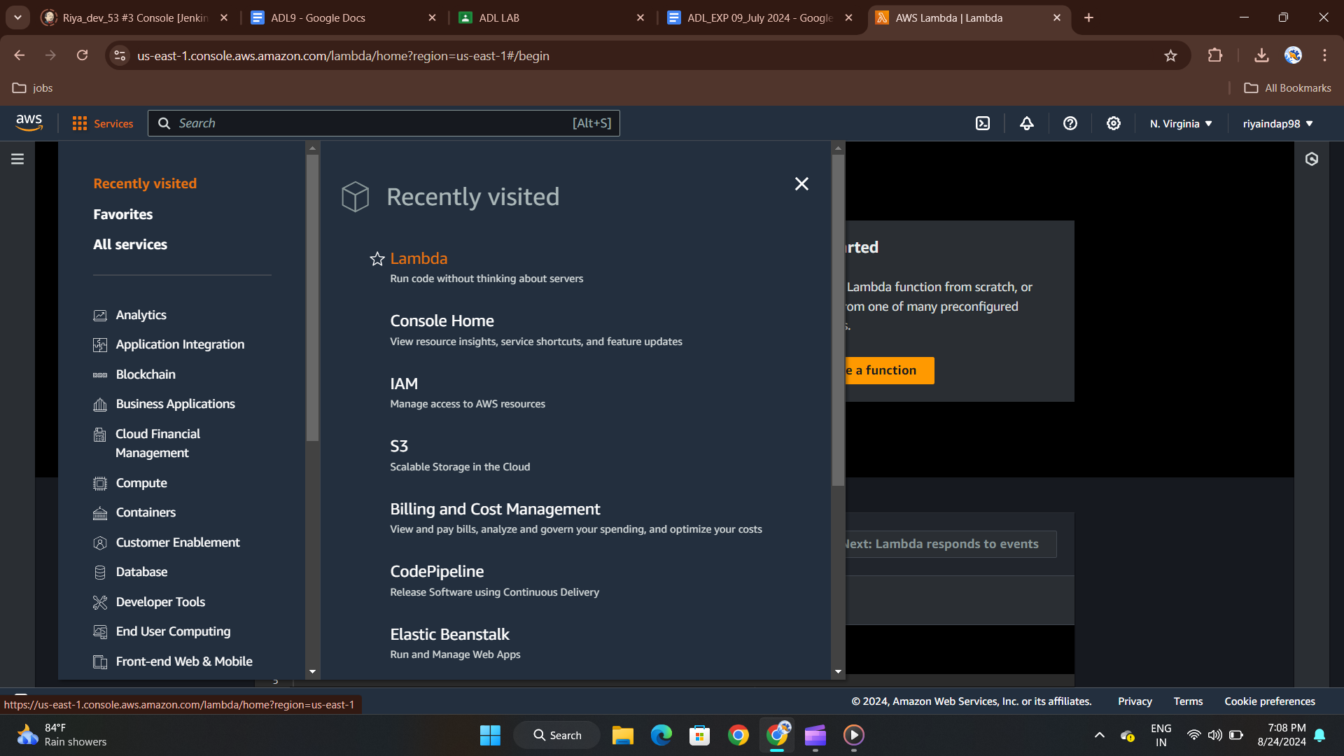

* Select a Lambda Blueprint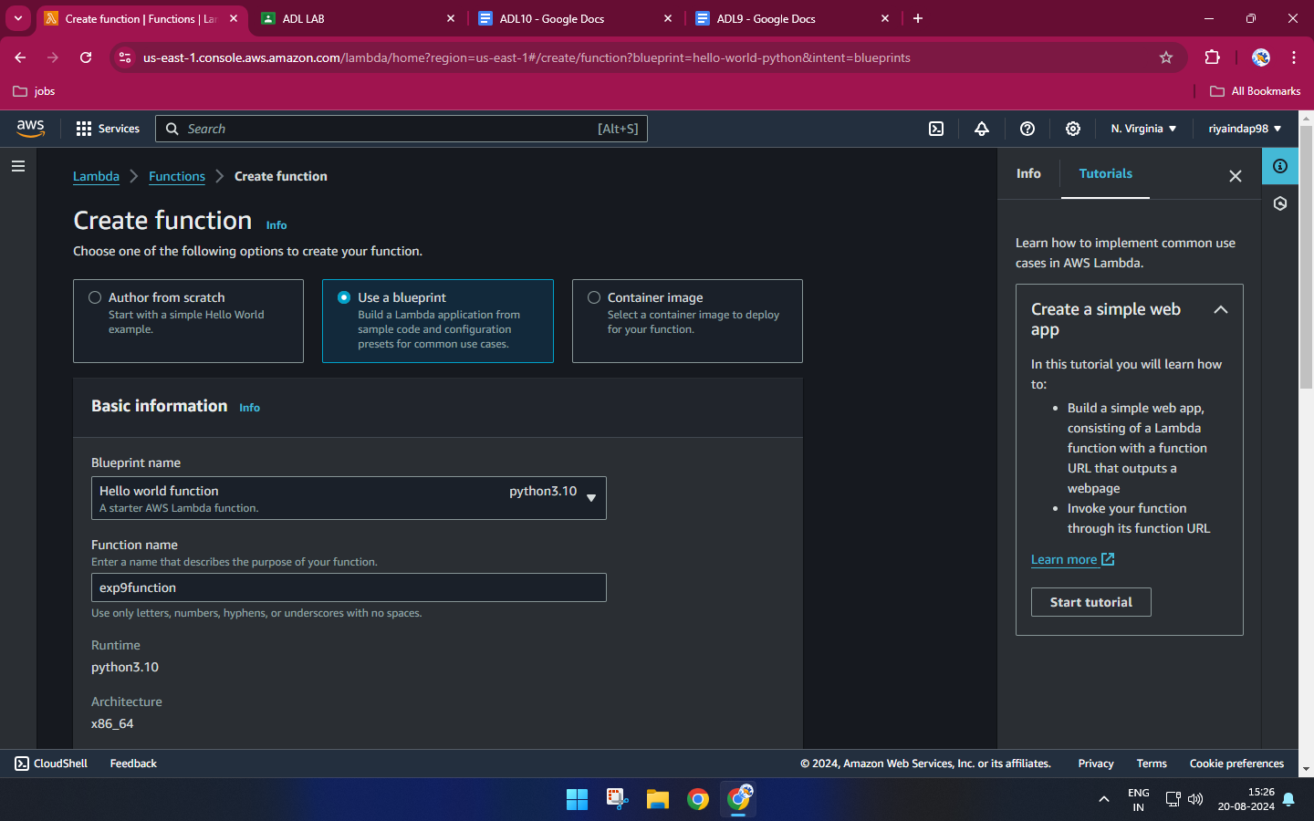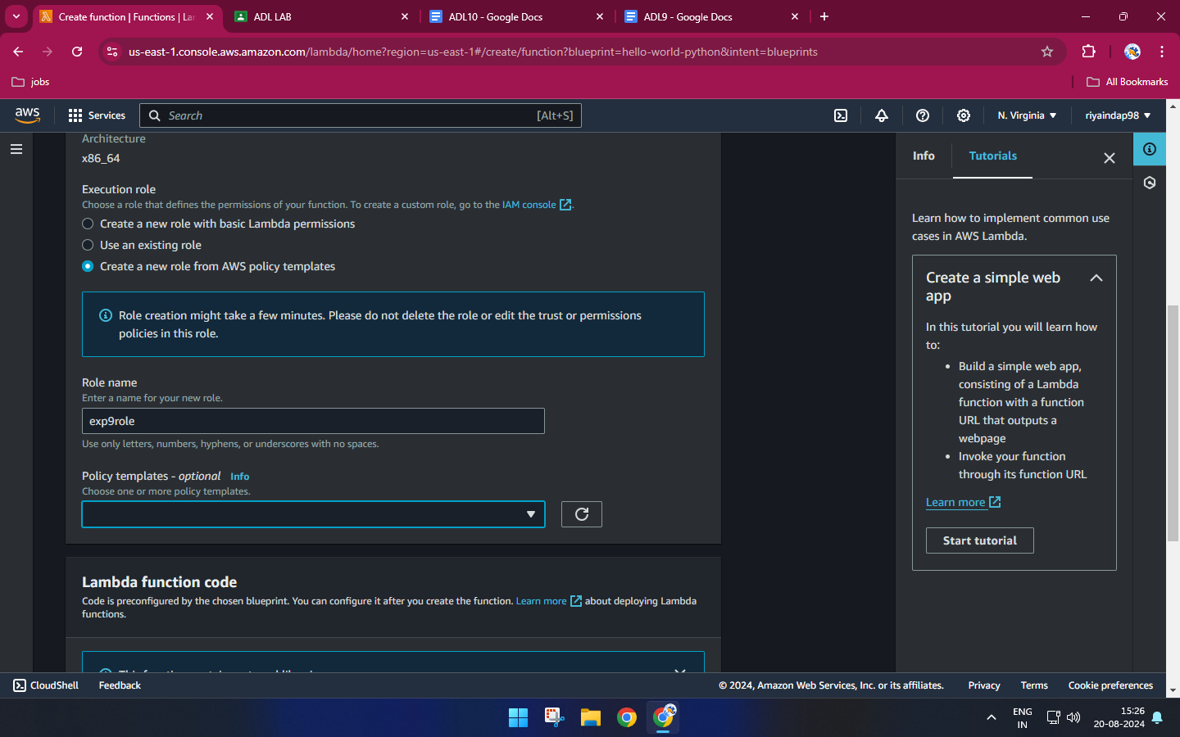
* Configure and create Lambda function

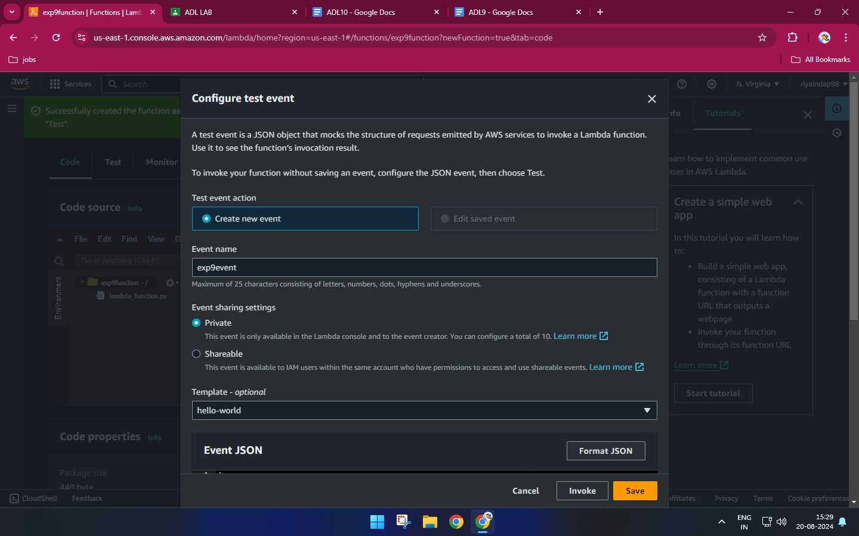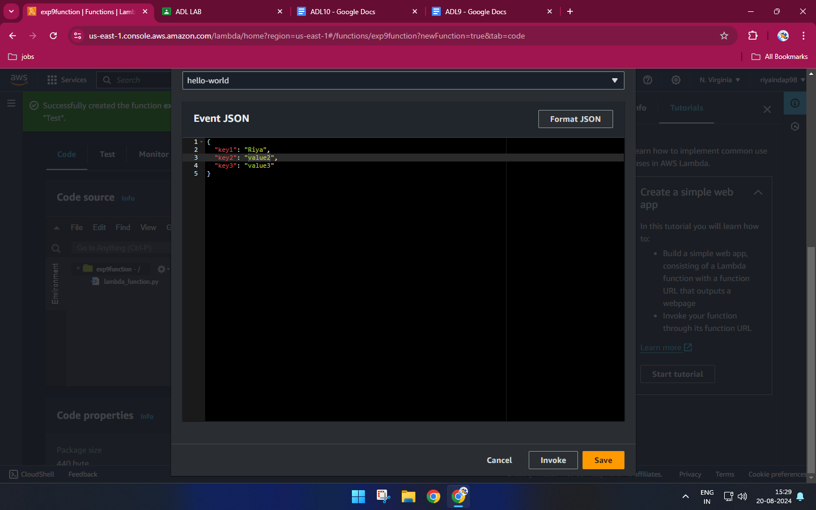

* Invoke Lambda function and verify results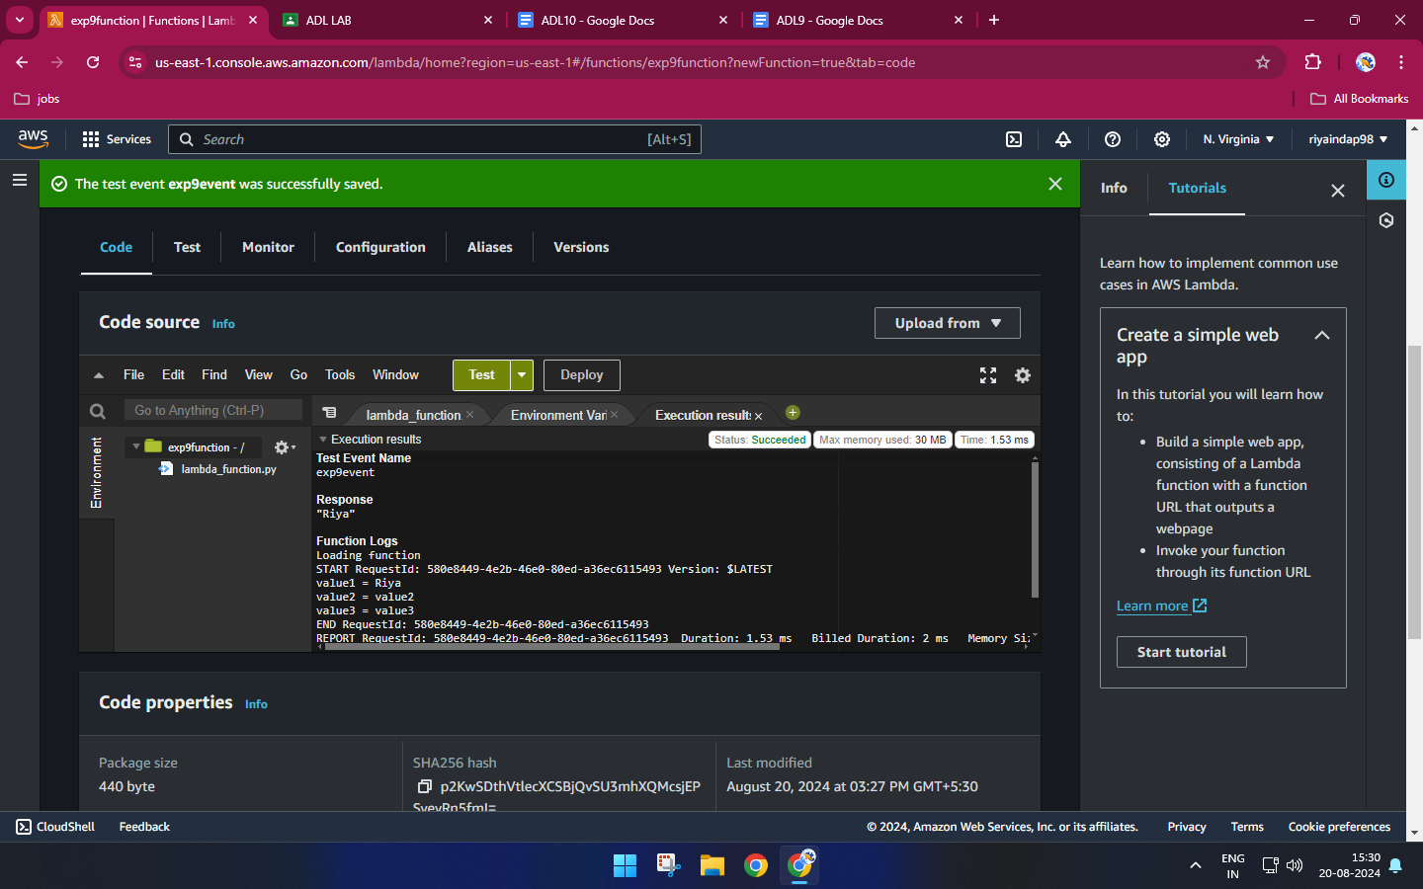
* AWS Lambda automatically monitors Lambda functions and reports metrics

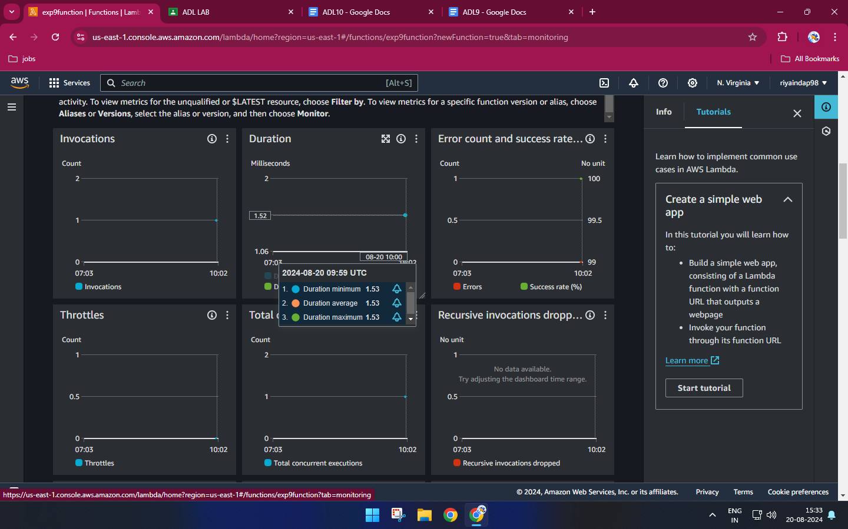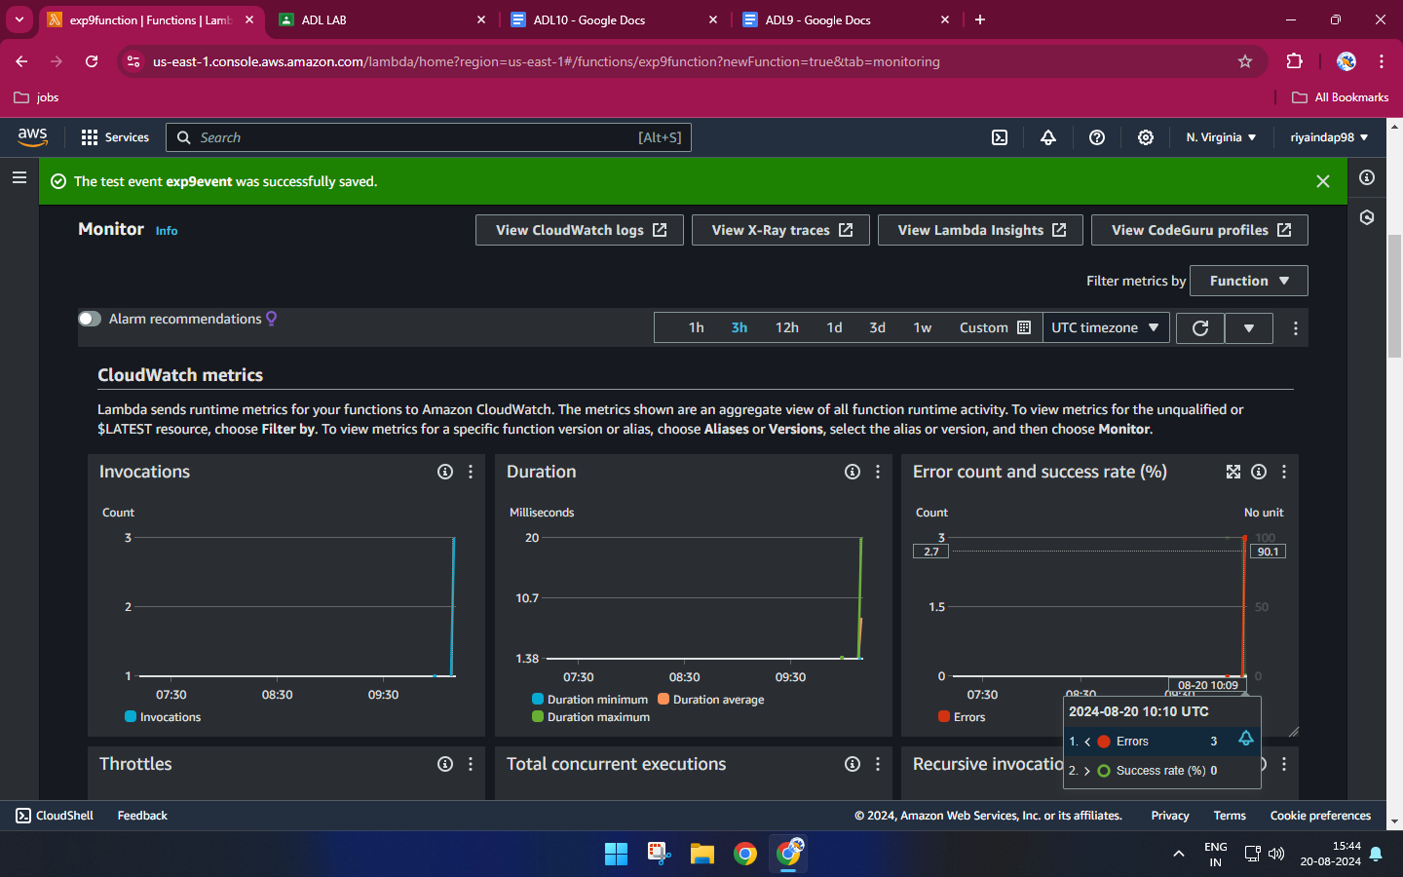

* Clean up Lambda function

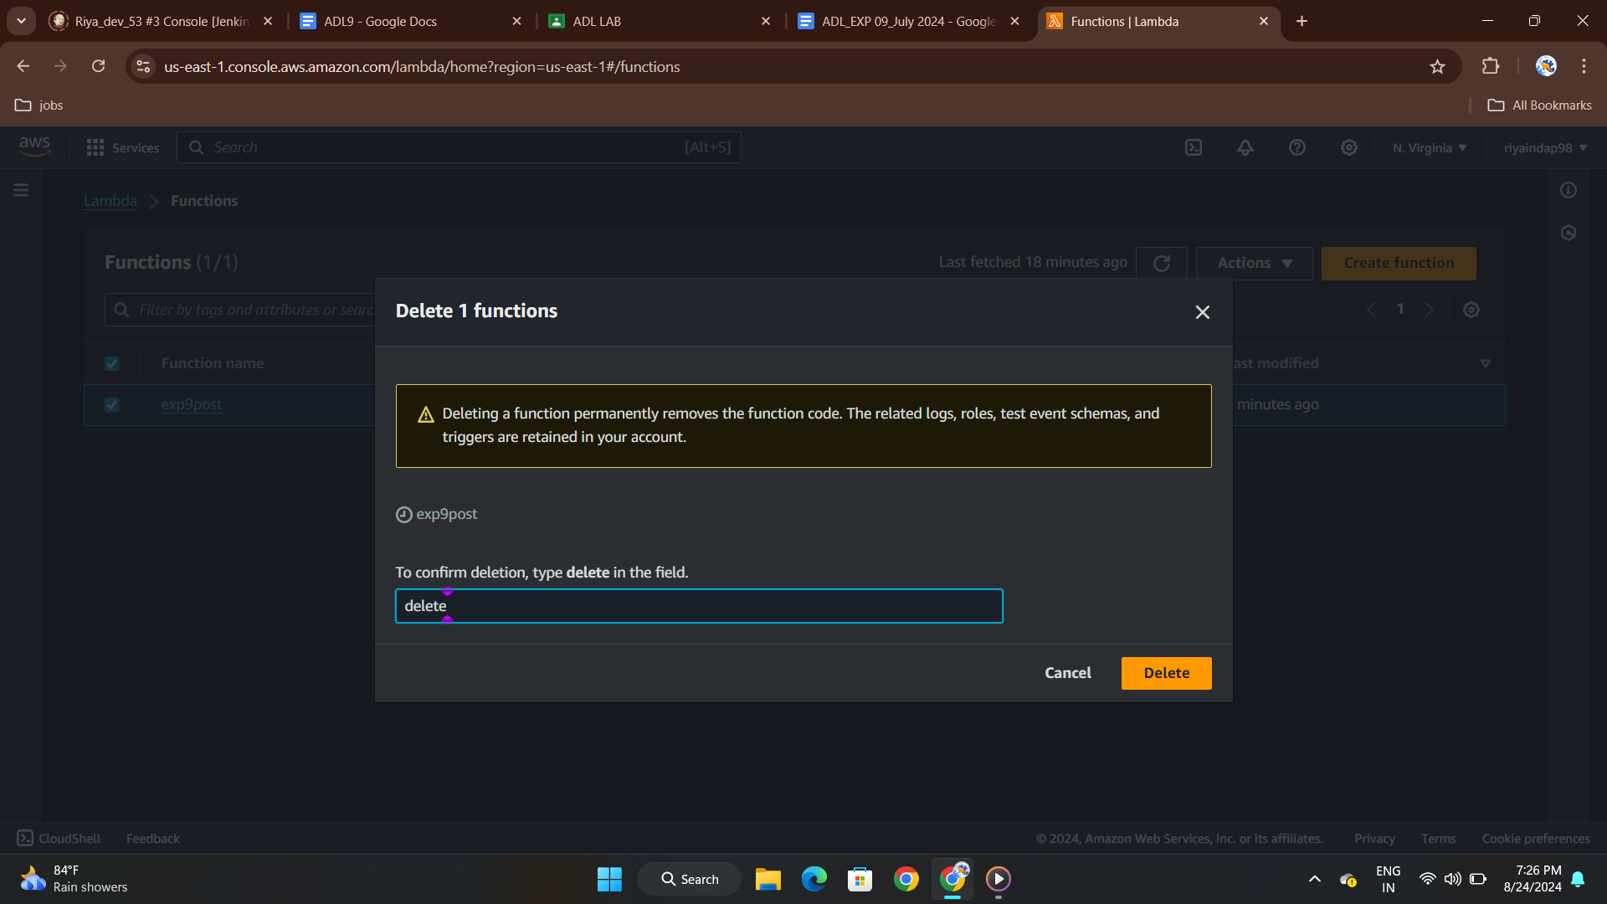

**Post-Experiment**

* Create the Lambda function using Node.js

